ASSIGNMENT NO 12
Q1 WRITE A QUERY THAT SELECT ALL CUSTOMER WHOSE RATING ARE EQUAL TO
OR GREATER THAN ANY OF SAREES’OR GREATER THAN ANY OF SAREES’
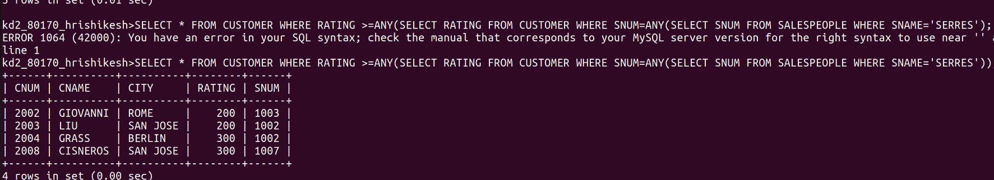

Q2 WRITE QUERY USING’ ANY’ OR’ ALL’ THAT WILL FIND ALL SALESPEOPLE WHO HAVE NO CUSTOMER LOCATED IN THEIRE CITY


Q3 WRITE QUERY THAT SELECT ALLL ORDER FOR AMOUNT S GREATER THAN ANY FOR THE CUSTORMERIN LANDON
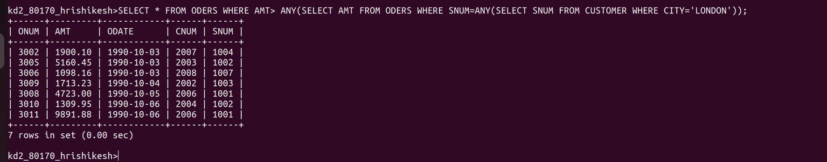
W
Q 4 WRITE THE ABOVE QUERY USING MIN AND MAX

